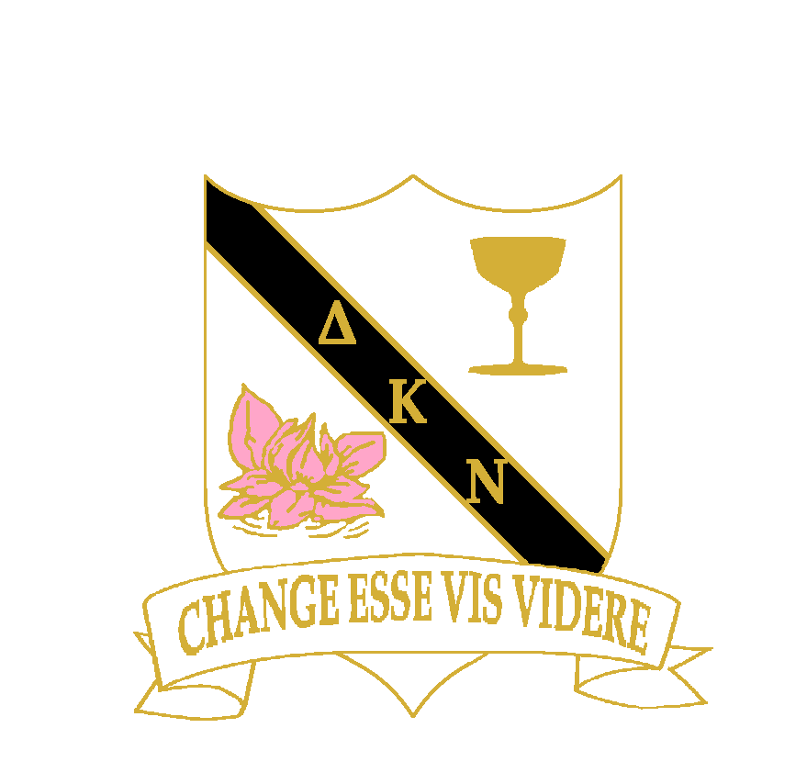

Dear

Be part of something Nu!

You are invited to consider becoming a part of Delta Kappa Nu Sorority.

So, what is a Sorority? A sorority is a womens-only Greek Letter Organisation. Traditionally set up as "literary societies", or drinking societies, they are denoted by their use of Greek Letters for their names.

Delta Kappa Nu is a social sorority, focused on social and philanthropic activities to improve members lives.

In reality, this means a group of gal pals who get together monthly, to share and celebrate their lives and make charitable contributions to worthy causes.

This is an invitation-only sorority, so you are getting this invite because we would love to consider you for membership and have you as our sister.

So, please come to our High Tea and consider becoming part of ΔΚΝ.

Where:

When:

RSVP:

With much love,

Delta Kappa Nu